Persistent Data: Bind Mounting (file sharing from host to container)

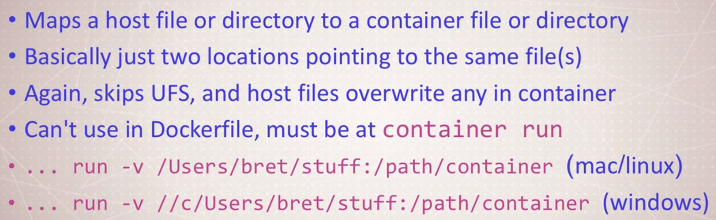

Copy files from **local location to container: -**

docker container run -d --name nginx -p 100:80 -v **//D/Docker/DockerFileDemo/dockerfile-sample-2:/usr/share/nginx/html** nginx

Local Location nginx server location

docker container exec -it nginx bash

* Changing on local file will automatically update the container file
* Here container & local files have same shared location

**Updating a postgres database from 9.6.1 to 9.6.2**

**Problem Statement: -**

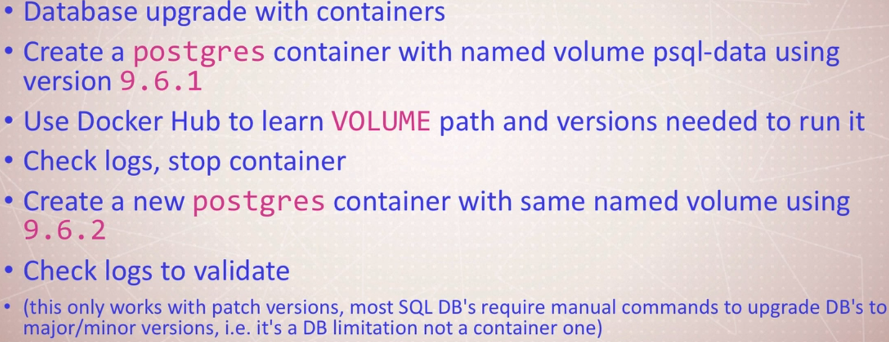

**Solution: -** Removing a container removes all data associated with it, but in case of volumes they are not removed. So, what we can do? We can simply create a named volume having the same name as the old volume and run the command below,

As, we know if there is an existing volume named *xyz*, if we **run** the commend with newer version of postgres it will simply update the previous one without data loss.

1. docker container run -d --name psql -v psql:/var/lib/postgresql/data postgres:9.6.1 (**Find it by tags: DockerHub)**
2. docker container logs -f psql
3. docker container stop psql
4. docker container run -d --name psql1 -v psql:/var/lib/postgresql/data postgres:9.6.2
5. docker container ps -a

CONTAINER ID IMAGE COMMAND CREATED STATUS PORTS NAMES

**b6b6d31f6776** postgres:9.6.2 "docker-entrypoint.s…" 15 seconds ago Up 13 seconds 5432/tcp psql1

a7084a104944 postgres:9.6.1 "/docker-entrypoint.…" 2 minutes ago Exited (0) 54 seconds ago psql

1. docker volume ls
2. docker container logs **b6b6d31f6776**